**ASSIGNMENT # 2**

**Due Date 8 Oct 2012** **In hard copy (Typed or hand writen)**

**Question No 1**. Differentiate and explain with the help of an example type of addresses (Physical, Logical, Port and Specific addresses)?

**Answer:** Through logical address the system identify a network (source to destination). after identifying the network physical address is used to identify the host on that network. The port address is used to identify the particular application running on the destination machine.  
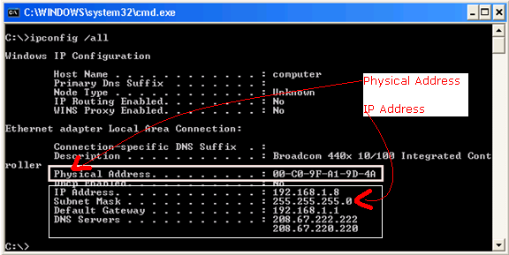

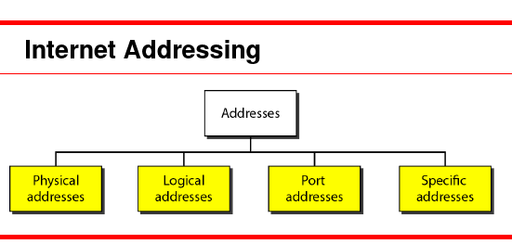

1. **Physical address**: Each system having a NIC(Network Interface Card) through which two systems physically connected with each other with cables. The address of the NIC is called Physical address or Mac address. This is specified by the manufacture company of the card. This address is used by data link layer.

a. Frames need to be transmitted to different systems on a network.

b. Data link layer adds a HEADER to frame.

c. Header defines the physical address of sender (Source address) and receiver address (Destination address).

d. Frame is intended for a device outside the network.

**Example:**



2. **Logical Address:**An IP address of the system is called logical address. This address is the combination of Net ID and Host ID. This address is used by network layer to identify a particular network (source to destination) among the networks. This address can be changed by changing the host position on the network. So it is called logical address.

a. If a packet is going from one network to another, need another addressing system to help distinguish source and destination systems

b. Network layer adds Header to the data coming from upper layers that among other things include LOGICAL ADDRESS of the sender and receiver.

**Example:**



3. **Port Address:** There are many applications running on the computer. Each application run with a port no(logically) on the computer. This port no. for application is decided by the Kernel of the OS. This port no. is called port address. Port address is a feature of a network device that translates TCP or UDP communications made between a host and port on an outside network.

1. It allows a single IP address to be used for many internal hosts.
2. Port address can automatically modify the IP packets' destination or source host IP and port fields belonging to its internal hosts.

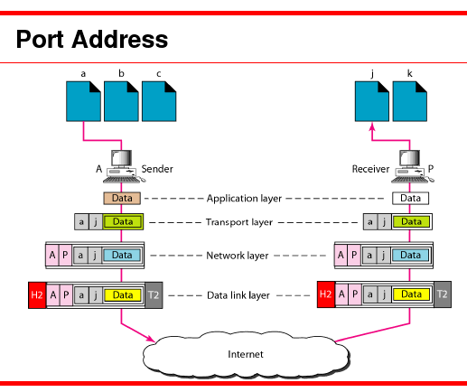

**Exapmples:** The port numbers are divided into three ranges: the well-known ports, the registered ports, and the dynamic or private ports. The well-known ports are those from 0 through 1023. Examples include:

* 20 & 21: [File Transfer Protocol](http://en.wikipedia.org/wiki/File_Transfer_Protocol) (FTP)
* 22: [Secure Shell](http://en.wikipedia.org/wiki/Secure_Shell) (SSH)
* 23: [Telnet](http://en.wikipedia.org/wiki/Telnet) remote login service
* 25: [Simple Mail Transfer Protocol](http://en.wikipedia.org/wiki/Simple_Mail_Transfer_Protocol) (SMTP)
* 53: [Domain Name System](http://en.wikipedia.org/wiki/Domain_Name_System) (DNS) service
* 80: [Hypertext Transfer Protocol](http://en.wikipedia.org/wiki/Hypertext_Transfer_Protocol) (HTTP)used in the [World Wide Web](http://en.wikipedia.org/wiki/World_Wide_Web)
* 110: [Post Office Protocol](http://en.wikipedia.org/wiki/Post_Office_Protocol) (POP3)
* 119: [Network News Transfer Protocol](http://en.wikipedia.org/wiki/Network_News_Transfer_Protocol) (NNTP)
* 143: [Internet Message Access Protocol](http://en.wikipedia.org/wiki/Internet_Message_Access_Protocol) (IMAP)
* 161: [Simple Network Management Protocol](http://en.wikipedia.org/wiki/Simple_Network_Management_Protocol) (SNMP)
* 443: [HTTP Secure](http://en.wikipedia.org/wiki/HTTP_Secure) (HTTPS)

4. **Specific Address.** A storage address which directly, without any modification, accesses a location or device is called a specific address. Specific or static, each computer has an address, most of the time a TCP/IP address in a pattern of four sets of three numbers.

Some applications have user-friendly addresses that are designed for that specific address. These addresses get changed to the corresponding port and logical addresses by the sending computer.

The e-mail address Universal Resource Locator (URL) (for example, [www.network-model.com](http://www.network-model.com)). The first defines the recipient of an e-mail; the second is used to find a document on the World Wide Web.

[www.hotmail.com](http://www.hotmail.com) etc.

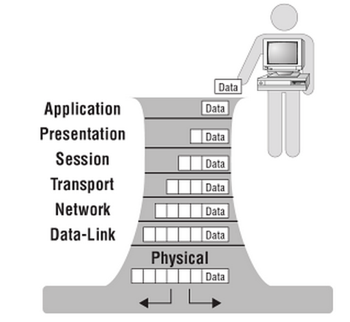**Question No 2**. Briefly describe the responsibilities of each OSI Model Layers?

**Answer:** The International Standards Organization, or the International Organization of Standards, (ISO) is a multinational body dedicated to worldwide agreement on international standards. An ISO standard that covers all aspects of network communications is the Open Systems Interconnection (OSI) model.

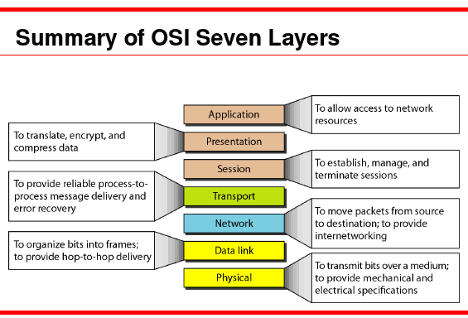

1. **The physical layer** is responsible for transmitting a bit stream over a physical medium. It is concerned with

a. Physical characteristics of the media

b. Representation of bits

c. Type of encoding

d. Synchronization of bits

e. Transmission rate and mode

f. The Way devices are connected with each other and to the links

2. **Data link layer** is responsible for

a. Framing data bits

b. Providing the physical addresses of the sender/receiver

c. Data rate control

Sol-02.fm Page 1 Saturday, January 21, 2006 10:27 AM2

d. Detection and correction of damaged and lost frames

3. **The network layer** is concerned with delivery of a packet across multiple networks; therefore its responsibilities include

a. Providing host-to-host addressing

b. Routing

c. Logical Addressing

d. Datagram Encapsulation

e. Fragmentation and Reassembly

f. Error Handling and Diagnostics

4. **The transport layer** oversees the process-to-process delivery of the entire message.

It is responsible for

a. Dividing the message into manageable segments

b. Reassembling it at the destination

c. Flow and error control

d. Process-Level Addressing

e. Multiplexing/De-multiplexing

f. Acknowledgments and Retransmissions

g. Flow Control

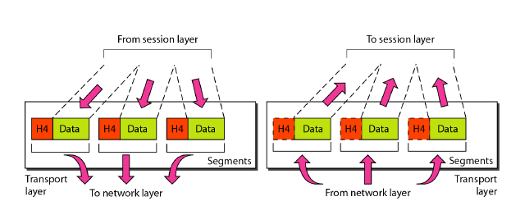5. **Session Layer**

a. Session Establishment

b. Management and Termination

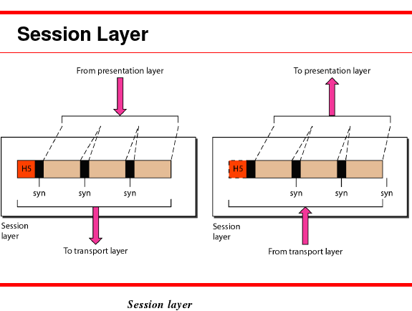

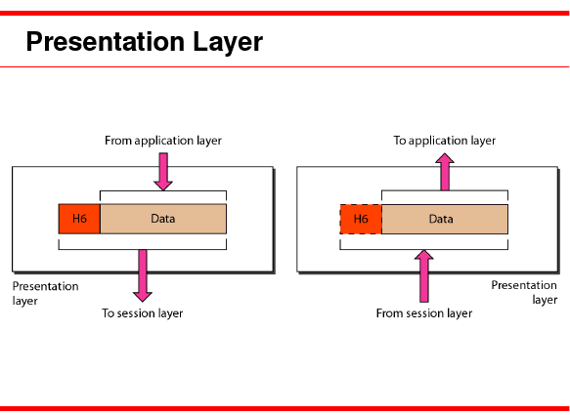6. **Presentation Layer**

a. Data Translation

b. Compression

c. And Encryption

7. **The application layer** User Application Services include

a. File transfer

b. Remote access

c. Shared database management

d. And mail services.

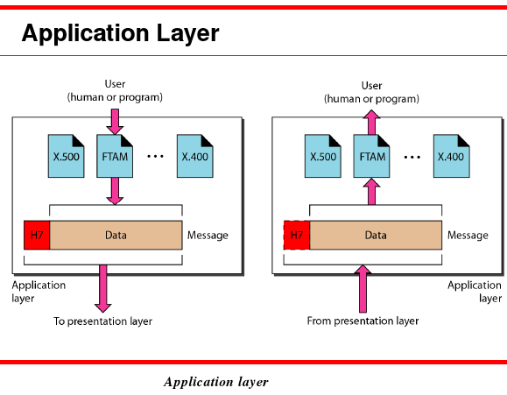

**Question No 3**. Explain with the help of diagram Hop by Hop delivery (Data link Layer), Packet by packet source to destination delivery (Network Layer), process by process source to destination delivery (Transport Layer)?

**Answer:**

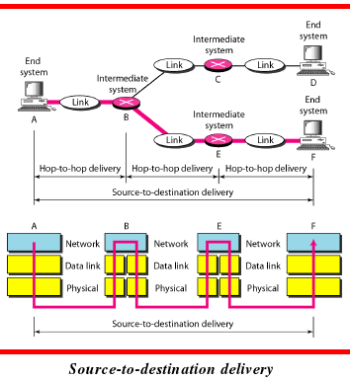**1.**  **Hop by Hop delivery: Datalink layer:** Hop-to-hop delivery means delivery of packets from the host's network interface card (NIC) to the router's interface. In hop-to-hop delivery, physical addresses of the devices are used to identify devices. The format of a physical address depends on the network type.

**2.**  **Packet by packet source to destination delivery (**Network Layer**),**Packets also contain addressing information. The receiver's address needs to be attached to the packet and the sender's address is also typically required to be present. The addresses in the packets don’t have to be related to any data link address in any direct way.

**3.**  **process-to-process delivery:** The transport layer in a network model is responsible for process-to-process delivery of the entire message, provides end-to-end communication services for applications. A process is an application program running on a host. It treats each one independently, as though each piece belonged to a separate message. The transport layer ensures that the whole message arrives intact and in order, overseeing both error control and flow control at the source-to-destination level.

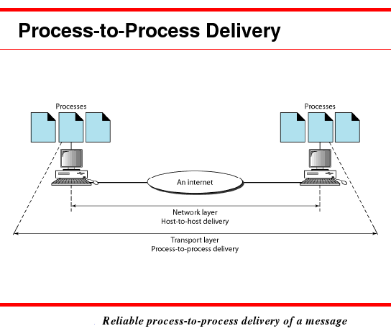

**Question No 4**. Differentiate following with the help of examples in your own words:-

1. Analog and digital data
2. Analog and Digital signal
3. Periodic and Aperiodic Signal
4. Period and Freq
5. Attenuation, Noise and distortion and type of noises

**Answer:**

a. **Analog (or analogue) data** is real world stuff like sounds, electrical currents, paintings, temperatures, time. It has no precisely measurable or discrete value - we measure to the accuracy of our recording instruments.

**For example**, an **analog clock** that has hour, minute, and second hands gives information in a continuous form; the movements of the hands are continuous. On the other hand, a **digital clock** that reports the hours and the minutes will change suddenly from 8:05 to 8:06.

**Digital data**, on the other hand is **discrete**, consider the **bitmap** as compared to an original image for example, a bitmap is made up of discrete pixels in one colour or another, the water-colour is not.

When **sounds are digitised** they must be stored as discrete values representing the pitch, volume, duration and other qualities of the sound Analog data, such as the **sounds made by a human voice**, take on continuous values. When someone speaks, an analog wave is created in the air. This can be captured by a microphone and converted to an analog signal or sampled and converted to a digital signal.

**For example**, data are **stored in computer** memory in the form of **Os and 1s**. They can be converted to a digital signal or modulated into an analog signal for transmission across a medium.

**b. Analog and Digital signal**

**Answer:**

Signals can be analog or digital. Analog signals can have an infinite number of values in a range; digital signals can have only a limited number of values.

**Example** **–** **Analog Signal**:

1. **Example** of an analog device is a non-digital thermometer measuring a constantly changing temperature. The action is continuous and the range is not very limited, though sometimes we wish it were. The data produced by a thermometer is analogous to the change in temperature. Therefore, it is **an analog signal**.

2. Another **example** is when we copy a videotape. Since video recorders are analog machines, copying a tape several times results in the accumulation of unwanted analog values called "noise". Eventually these signals become so evident, that the original analog signal is compromised and the video "dub" suffers from intense graininess and poor audio sound.

**Digital signals**, on the other hand, are distinctively different. Digital signals don't have large ranges, nor do they reflect constant activity. Digital signals have very few values. Each signal is unique from a previous digital value and unique from one to come. In effect, a digital signal is a snapshot of a condition and does not represent continual movement.

**Example** **–** **Digital Signal**

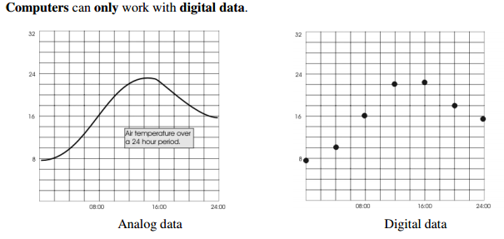

**Comparison of Analog and Digital signals**



c. Periodic and Aperiodic Signal

**Answer:** In data communications, we commonly use periodic

analog signals and aperiodic digital signals.

Both analog and digital signals can take one of two forms: periodic or nonperiodic (sometimes refer to as aperiodic, because the prefix a in Greek means "non").

A periodic signal completes a pattern within a measurable time frame, called a period, and repeats that pattern over subsequent identical periods. The completion of one full pattern is called a cycle. A aperiodic signal changes without exhibiting a pattern or cycle that repeats over time.

Both analog and digital signals can be periodic or aperiodic. In data communications, we commonly use periodic analog signals (because they need less bandwidth,

d. **Frequency** is the number of occurrences of a repeating event per unit [time](http://en.wikipedia.org/wiki/Time). It is also referred to as **temporal frequency**. The **period** is the duration of one [cycle](http://en.wikipedia.org/wiki/Turn_(geometry)) in a repeating event, so the period is the [reciprocal](http://en.wikipedia.org/wiki/Reciprocal_(mathematics)) of the frequency.

http://www.physicsclassroom.com/class/waves/u10l2b1.gif

http://www.physicsclassroom.com/class/waves/u10l2b2.gif

**Example**, if a newborn baby's heart beats at a frequency of 120 times a minute, its period (the interval between beats) is half a second.

e. Attenuation, Noise and distortion and type of noises

**Answer:** Signal travel through transmission media, which are not perfect. The imperfection causes signal impairment. This means what is sent is not what is received. Three types of transmission impairment are attenuation, distortion, and noise.

1. Attenuation means loss of energy

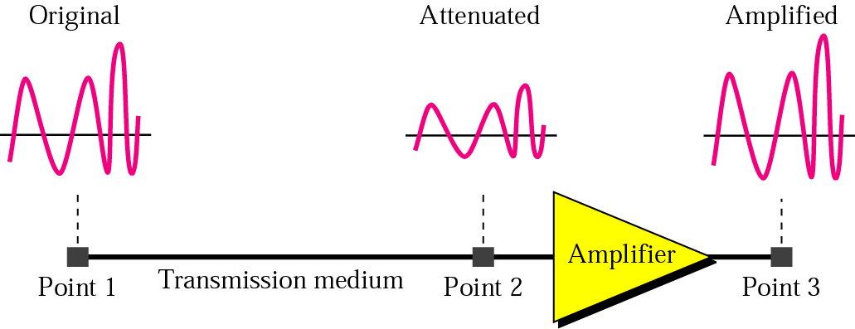

2. Distortion means that signal changes its form or shape

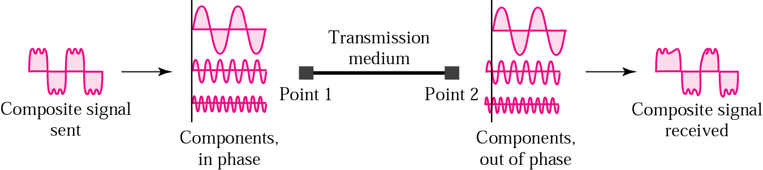

3. Several types of noise such as thermal noise, induced noise, crosstalk and impulse noise may corrupt the signal.

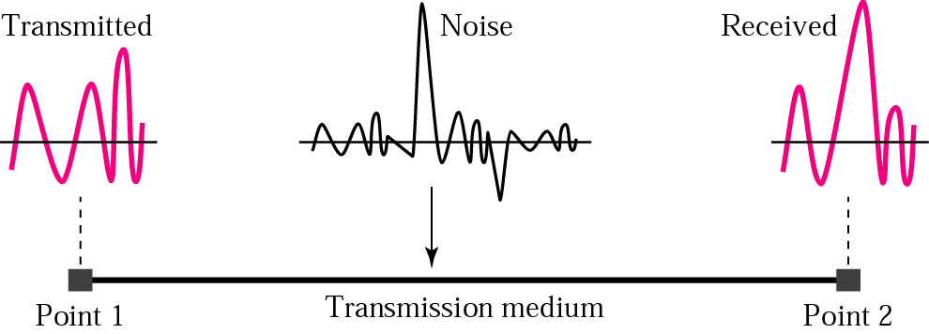

**Question No 5**. Draw and explain how a square wave can be constructed from sine wave.

**answer:**

http://www.slack.net/~ant/bl-synth/images/ideal_square.gifAn ideal square wave is a simple oscillation between two amplitudes, without any intermediate values:

The square wave contains a fundamental and a series of ODD HARMONICS; that is harmonics which are odd number multiples of the fundamental (x3 x5 x7 etc.) These are called the 3rd harmonic, 5th harmonic etc.

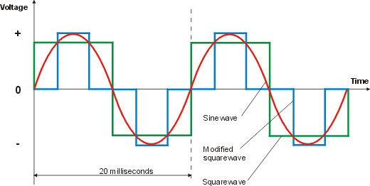

A square wave can be constructed from multiple sine waves at different frequencies. The sine waves added in addition to the fundamental frequency are called *harmonics*; a square wave has harmonics at odd multiples of the fundamental frequency. As higher harmonics are added, the result gets closer to an ideal square wave, which contains infinite harmonics.

sin(angle) + sin(3*angle)/3 + sin(5*angle)/5 + sin(7*angle)/7 + ...

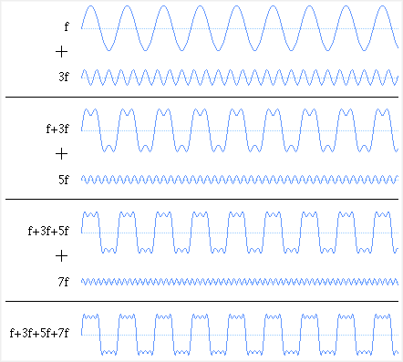

**Question No 6**. Explain bandwidth for digital and analog Signals?

**Bandwidth**

Bandwidth describes the amount of data that can be sent through a data-transmitting medium, such as a computer network, telephone line, or coaxial cable in a given amount of time. All transmitted signals whether analog or digital have a certain bandwidth, as do receiving systems. Bandwidth is directly proportional to the amount of data transmitted or received per unit of time.  
  
 Bandwidth is therefore also proportional to the complexity of data for a given level of system performance. For example, it takes more bandwidth to download a photograph in one second than it takes to download a page of text in one second.  
  
**Digital Systems**  
 In digital systems, digital devices, and devices that process data in coded combinations of binary digits, bandwidth is usually expressed either as a transmission rate called baud or in bits per second (bps). A bit is the smallest unit of information a computer uses. It may have a value of either 0 or 1, and physically corresponds to whether a transistor in the computer is on or off. Combining bits into larger units called bytes creates more meaningful information. Thus, a modem that works at 57,600 bps has twice the bandwidth of a modem that works at 28,800 bps.  
  
  
**Analog Systems**  
  
 In analog systems, and for analog devices, bandwidth is defined in terms of the difference between the highest-frequency signal component, and the lowest-frequency signal component. Frequency is measured in cycles per second (hertz). A typical voice signal has a bandwidth of approximately three kilohertz (3 kHz); an analog television (TV) broadcast video signal has a bandwidth of six megahertz (6 MHz) -- some 2,000 times as wide as the voice signal. Standard telephone lines are analog and have a low bandwidth. They can only transmit data at a maximum speed equivalent to about 14,400 bps.

**Digital Vs Analog Bandwidth**

In **analog design** the concept of bandwidth is related to the frequency at which the output will drops it's power by 1/2 the maximum.  
  
In **digital the bandwidth** is nothing but the bit rate  possible through the channel .. it is wrong terminology to use but the comp science ppl can't help stealing analog ppl's vocab .. anyway the maximum bits  
per second is related to the analog bandwidth by the very famous relation given by Shanon .. i.e.  
  
C = BW * log_2 ( 1 + S/N)  
  
Where   
  
C = Channel capacity in Bits per secodn  
  
BW= Analog bw available in channel   
S/N = Signal to Noise ration   
  
but sill the bandwidth in Digital depends on several  
things like signal format like RZ, NRZ and Manchester etc..

**Analog bandwidth** is the maximum sinusoidal frequency of the analog signal the circuit works with.  
  
But **digital bandwidth** of a circuit is different.   
  
**Digital bandwidth** of a circuit is less than analog bandwidth because digital signals are made of 1 and 0 values and these are square wave signals. If you plot the frequency spectrum of the square wave the maximum frequency content in the signal is more than the frequency of the square wave.  
  
For example the Fourier transform of a 1MHz clock signal contains harmonics at much higher frequencies. Therefore in order to work at clock frequency of 1MHz a circuit bandwidth has to be more than 1MHz.  
  
But in analog circuit if the highest frequency of the signal is 1MHZ then your circuit BW needs to be only 1MHz.

**Question No 7**. 

**Answer:**

a. 90 degrees (π/2 radian)

b. 0 degrees (0 radian)

c. 90 degrees (π/2 radian)

**Question No 8**. If we experience a string of zeros of different lengths, what line coding scheme will suit these conditions? Explain with the help of diagram for at least 20 bits.